1. 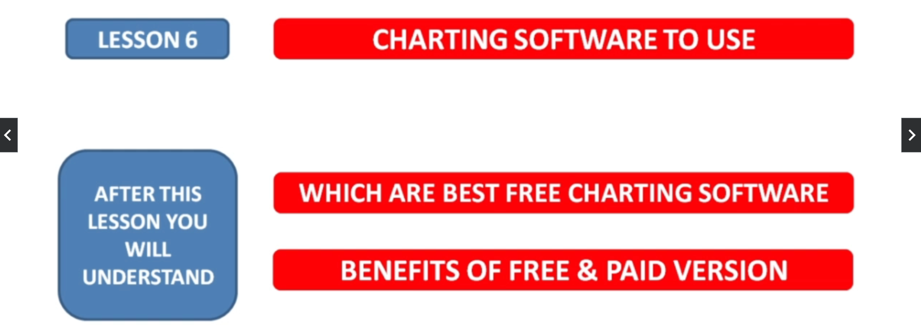
2. Chartink.com
3. Tradingview.com